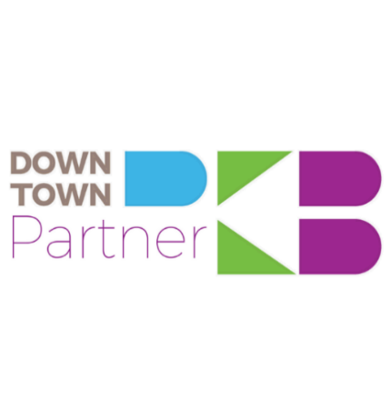 **Friends of Downtown PKB - $100 or more** *(Available to individuals only)*

* Advance online purchase of tickets and/or reserved seating for select Downtown PKB events.
* Recognition on website.
* Invitation to attend our annual meeting in February.

**Supporter - $250**

* Advance online purchase of tickets and/or reserved seating for select Downtown PKB events.
* Recognition on website.
* Promotion on Downtown PKB social media sites (over 13,100 Facebook and 2,400 Instagram followers). ***Content must be provided by business.***
* Vinyl cling for display at the business/organization. (If new to program or need replacement.)
* Invitation to attend our annual meeting in February.

**Advocate - $500**

* Advance online purchase of tickets and/or reserved seating for select Downtown PKB events.
* Recognition on website with business or organization logo & link.
* Promotion on Downtown PKB social media sites, (over 13,100 Facebook and 2,400 Instagram followers). ***Content must be provided by business.***
* Logo on scrolling banner on PKB website.
* Vinyl cling for display at the business/organization. (If new to program or need replacement.)
* One article in News/Sentinel Downtown PKB column. Article will also be added to Downtown PKB’s newsroom located on website. ***Content must be provided by business.***
* Invitation to attend our annual meeting in February.

**Champion - $1,000**

* Advance online purchase of tickets and/or reserved seating for select Downtown PKB events.
* Recognition on website with business or organization logo & link.
* Promotion on Downtown PKB social media sites, (over 13,100 Facebook and 2,400 Instagram followers). ***Content must be provided by business.***
* Logo on scrolling banner of PKB website.
* Vinyl cling for display at the business/organization. (If new to program or need replacement.)
* One article in News/Sentinel Downtown PKB column. Article will also be added to Downtown PKB’s newsroom located on website. ***Content must be provided by business.***
* Inclusion in a Downtown PKB promotional video located on Downtown PKB website.
* Recognition at all Downtown PKB events including annual meeting.
* Invitation to attend our annual meeting in February.

**Visionary - $2,500**

* Advance online purchase of tickets and/or reserved seating for select Downtown PKB events.
* Recognition on website with business or organization logo & link.
* Promotion on Downtown PKB social media sites, (over 13,100 Facebook and 2,400 Instagram followers). ***Content must be provided by business.***
* Logo on scrolling banner of PKB website
* Vinyl cling for display at the business/organization. (If new to program or need replacement.)
* Two articles in News/Sentinel Downtown PKB column. Articles will also be added to Downtown PKB’s newsroom located on website. ***Content must be provided by business.***
* Inclusion in a Downtown PKB promotional video located on Downtown PKB website.
* Recognition at all Downtown PKB events including annual meeting.
* Reserved seating for eight (8) at the annual Taste of Parkersburg event, four (4) tickets to the Downtown Throwdown, and two (2) chairs to the Point Park Concert Series.
* Invitation to attend our annual meeting in February.

A Main Street Community

***When you invest in Downtown PKB, you are investing in your entire community.***

Benefits are available based on gift commitment date and must be renewed annually. If fees are paid past deadline, the renewal month will remain the same. Online payment will be accepted but will include a convenience fee of 2.5%. Downtown PKB is a registered, 501(C) (3) organization and all donations are tax-deductible.   
  
Rev. Oct. 2024